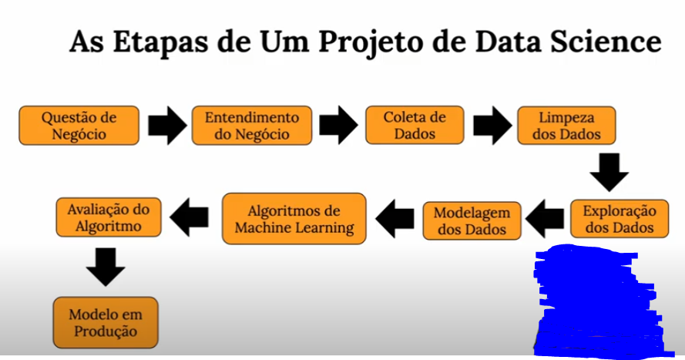

Date analistic --- projetos do tipo insights

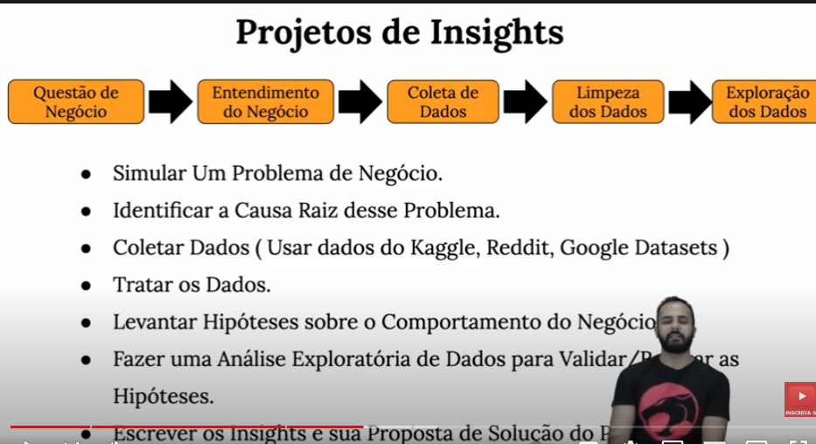

Projetos data engineering

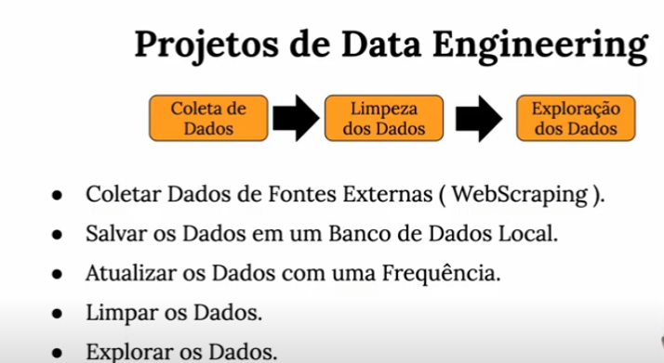

Projetos de machine learning

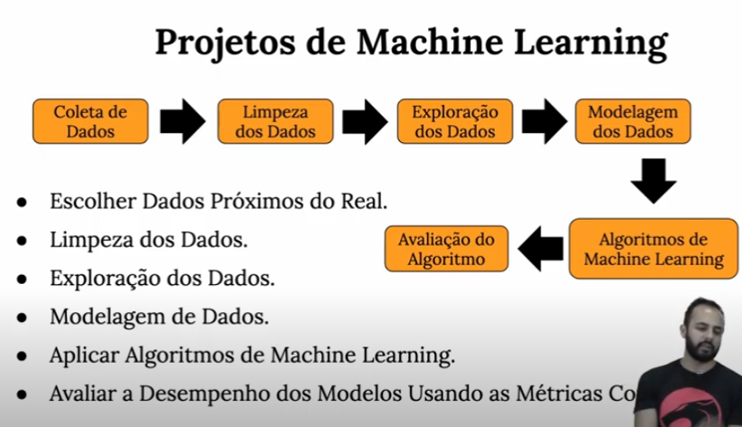

Projetos end-to-end

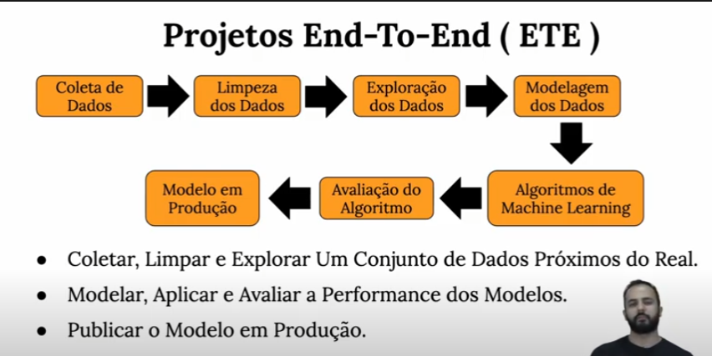

Projetos de data Science

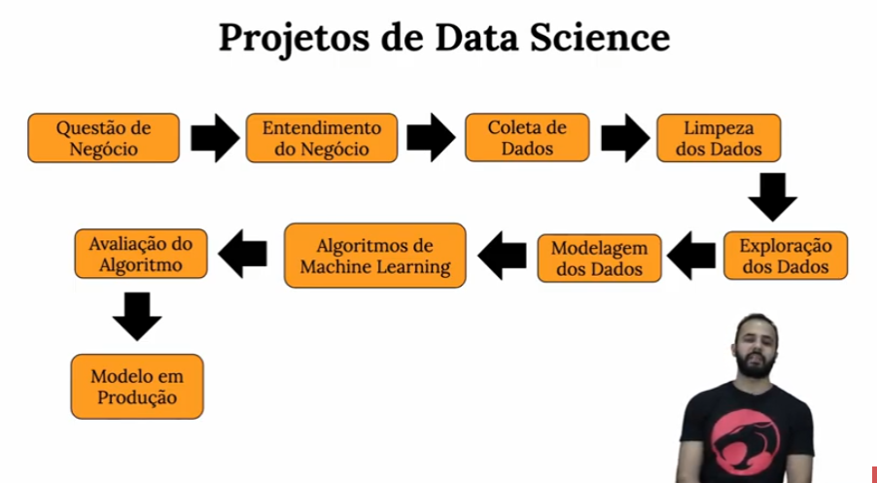

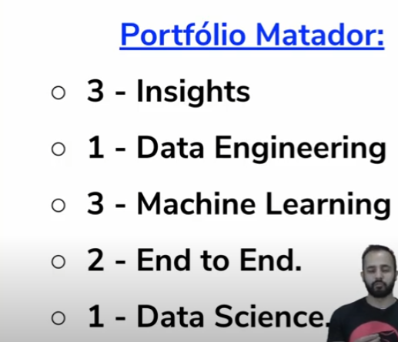

Funções do data engineering

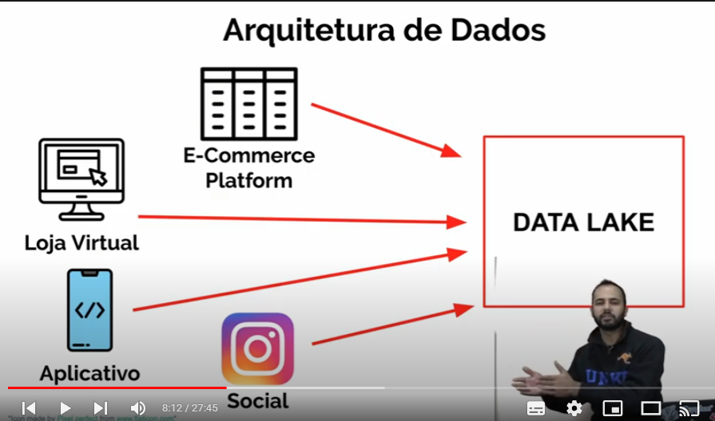

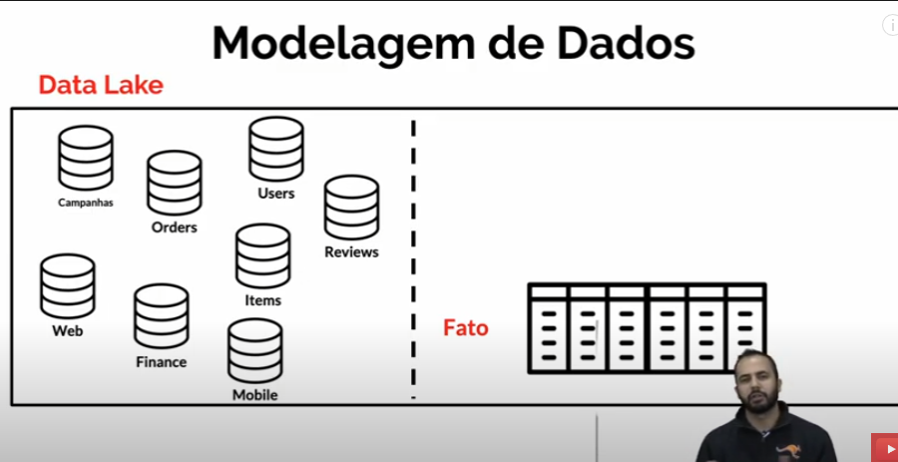

<https://www.youtube.com/watch?v=hl_6VVj8A_U&list=PLZlkyCIi8bMpd6SZI2nNpu97BxfkLc5rs>

https://www.youtube.com/watch?v=VTuqrtD-524

<https://www.youtube.com/c/UniversoDiscreto/playlists>

<https://www.youtube.com/watch?v=dBZZ3I9GqLE&list=PL-t7zzWJWPtz29fAf72nG3KTJrRdvCmgn>

https://www.youtube.com/playlist?list=PLOw62cBQ5j9VE9X4cCCfFMjW_hhEAJUhU